The Marist Primary School |  |  | Knowledge Organiser |  |  |  | 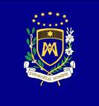
Spring 1 – Unit 3: Shapes and colours in Spanish
Lesson 1  Can I recognise and name some colours in Spanish? | Lesson 2  Can I begin to describe shapes using colour adjectives? | Lesson 3  Can I create and practise descriptive phrases orally? |  | Lesson 4  Can I read and recognise descriptive phrases in Spanish? | Lesson 5  Can I write a design brief using shape and colour vocabulary? | Lesson 6  Can I create a short presentation using descriptive phrases?


